Chapter 4, Solution 88

To find R_{Th,} consider the circuit below.

R_{Th} 5k
A B

30k 20k

10k
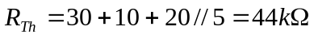

To find V_{Th} , consider the circuit below.

5k
A B
i_{o}
+
30k 20k
4mA 60 V
-

10k

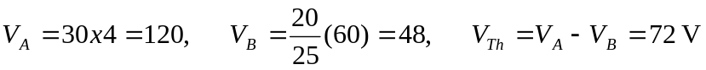
The Thevenin equivalent circuit is shown below.

44k
I

R_{i}
+
72 V
-

2k

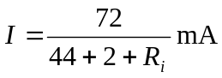
assuming R_{i} is in k-ohm.

- When R_{i} =500,
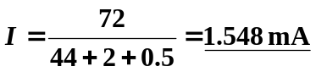

- When R_{i} = 0,

